**Musical Highlighting Application**

**Cosán Ceol – A Journey Through Irish Music**

**Rebecca Ann McGowan**

**13402658**

Final Year Project – 2017

B.Sc. Computer Science and Software Engineering



Department of Computer Science

Maynooth University

Maynooth, Co. Kildare

Ireland

A thesis submitted in partial fulfilment of the requirements for the B.Sc. Computer Science and Software Engineering.

Supervisors:

Mr. Thomas Lysaght,

Dr. Joseph Timoney,

Dr. Thanh Thoa Pham Thi

Contents

Declaration i

Acknowledgements ii

Abstract iii

List of Figures iv

List of Tables iv

**Chapter one: Introduction** 1

Summary 1

1.1 Topic addressed in this project 1

1.2 Motivation 1

1.3 Problem statement 1

1.4 Approach 1

1.5 Metrics 2

1.6 Project 2

**Chapter two: Technical Background** 3

Summary 3

2.1 Topic material 3

2.2 Technical material 3

**Chapter three: The Problem** 4

Summary 4

3.1 Project UML documentation 4

3.2 Problem analysis 4

**Chapter four: The Solution** 5

Summary 5

Depending on your type of project, you may not need to include all of these: 5

4.1 Analytical Work 5

4.2 Architectural Level 5

4.2 High Level 5

E.g. Packages, Class Diagrams, etc. 5

4.2 Low Level 5

E.g. Method specifications, Algorithms, etc. 5

4.2 Implementation 5

**Chapter five: Evaluation** 6

Summary 6

5.1 Solution Verification 6

E.g. use your equations to verify the correctness of your solution 6

5.2 Software Design Verification 6

5.3 Software Verification 6

5.3.1 Your test approach (i.e. unit testing, sub-system testing, system testing) 6

5.3.2 Your tests (e.g. scenarios, test cases, test data, etc.) 6

5.3.3 Your test results 6

5.3.4 An interpretation of the results 6

5.4 Validation/Measurements 6

5.4.1 Results 6

5.4.2 Explanation of Results 7

5.4.3 Analysis of Results 7

5.4.4 Comparison with previous solutions (if relevant) 7

**Chapter five: Conclusion** 8

**Summary** 8

**5.1** **Contribution to the state-of-the-art** 8

**5.2** **Results discussion** 8

**5.3** **Project Approach** 8

**5.3** **Future Work** 8

**References** 9

**Appendices** 10

Appendix 1 Schematic of the hardware associated with this project. 11

Appendix 2 Code developed for this project. 12

Appendix 3 UML Class, Use Case and sequence diagrams for this project. 13

Appendix 4 Screen shots of the project implementation 14

## Declaration

I hereby certify that this material, which I now submit for assessment on the program of study as part of B.Sc. Computer Science and Software Engineering qualification, is *entirely* my own work and has not been taken from the work of others - save and to the extent that such work has been cited and acknowledged within the text of my work.

Signed: Date:

## Acknowledgements

I would like to thank my supervisors, Mr Thomas Lysaght, Dr Joseph Timoney and Dr Thanh Thoa Pham Thi for their continuous help throughout the process of this project. Their guidance and feedback allowed me to progress. I would like to thank my classmates in their constant support during the project, providing feedback and helping with any testing I required. Lastly, I would like to thank all sources that have helped me achieve completion on this project.

## Abstract

The outline of the project is to create a music highlighting application with the aid of Google Maps. As we know, Google maps is an online mapping tool allowing users to search around the globe for locations. This project has incorporated this idea, with markers highlighting the history of Irish music, focusing solely on Ireland. There are many segments in Irish music, so it is important to display all segments to avoid isolating any. These segments can be divided as follows:

* Irish Traditional Music
* Folk Music
* Showbands
* Country Music
* Irish Rebel music

These categories have originated for different reasons, but all have become a key factor in identifying Irish culture. It is due to these categories that Ireland’s rich history and heritage is known and admired globally. This admiration has made Ireland an ideal location for festivals celebrating the rich history it beholds. However, not everyone knows where to look for this information. This project displays not only the musical talent it withholds, but displays upcoming events that celebrate it. The idea behind this application is to create a friendly user interface that shows where these musicians and festivals are taking place around Ireland. Unlike other applications, all this information will be in one place, making it an easy transition for its users. This approach has resulted in an interactive web application educating users on all there is to know about Ireland, and its musical history.

## List of Figures

Figure 3‑1 UML class diagram overview for this project. 4

## List of Tables

Table 2‑1 Table of interest: Aspect of your implementation 2

Table 2‑2 Data sources used in your implementation 2

# **Chapter one: Introduction**

## 1.1 Motivation

Ireland has a powerful history that has shaped not only its culture, but the culture of many other nations. This global recognition as pathed ways for many musicians to get the acknowledgement they may not have been exposed to otherwise. Music has become not only a hobby, but a way of life, a key part in society. “The power of music to influence mood and create scenes, routines and occasions is widely recognized and this is reflected in a strand of social theory from Plato to Adorno that portrays music as an influence on character, social structure and action.”(Earhart & Clarke, 1936). This influence has created the need for society to be educated on different genres of music. Ireland can be classified into many different genres, from the most widely known Irish Traditional Music, all the way to modern day pop. This broad categorisation makes Ireland an ideal location to host festivals highlighting all the talent it beholds.

One of the key identifiers in Irish culture is its Traditional music. Nations look to us to base their music culture on. The desire to replicate, has in turn created an admiration, and fan base wanting to learn more. This yearning makes this application extremely desirable. It allows users to keep up-to-date on any events happening but also allows users to learn about all the great musicians that have spread the sounds of our nation. Whether the user wants to learn about all types of music, or on a specific type, this application shall allow this to be done with ease and confidence. This web application avoids the current issue of having to source information via multiple sources, by withholding all required information in the one place. This novel approach allows all material to be accessible with ease.

Other projects have implemented some of these ideas previously. (INSERT INFORMATION ON PROJECT DONE BEFORE THIS – NEED THIS INFORMATION FROM SUPERVISORS).

Last year, Ireland celebrated its State Centenary, marking a hundred years since Ireland gained its own independence. (INSERT CITATION ON 1916). This celebration was broadcasted globally, sparking more interest into the history of Ireland. The broadcast reignited a want to learn more about Ireland’s historical past. This in turn results in a stronger need to have a resource where all information regarding Ireland’s musical talent can be accessed, engrossing the user to relax and listen to the blissful sounds. The application should highlight not only the music we have produced, but show the wide-ranging types of instruments and sounds that have come before us. Geographically, counties can be influenced by a certain type of instrument or sound, more than that of others, and the application should allow users to see this without any confusion.

## 1.2 Problem statement

In order to achieve in creating this web application, there are certain problems that must be addressed. These problems vary from gathering all the information on musicians and festivals, to implementing google maps API to display all this information. As stated, Ireland has an extremely diverse range of musical talent, so for the project, it was decided to focus on Traditional Irish music. This decision allows us to branch into sectors such as folk music, showbands and much more as many musicians started off with a traditional music background.

Classification of some musician’s genres can cause some problems. It is a natural progression for musicians to experiment in many different genres as they grow with their musical talent. This issue can cause confusion in classification as some of the public may know them for one genre whereas the rest know them as another. For this reason, the application needs to highlight this. Festivals have become an imperative way in celebrating music.  “Festivals can contribute to arts development by creating demand for the arts, enhancing venue infrastructures, encouraging local creativity and animating local involvement” (Quinn, 2006). As it has become a way of educating and highlighting local talent, the application needs to be able to give as much information as possible to its users. The users need to be able to get the information they require, and buy tickets if needs be to these events.

This wide range of musical types can cause a problem with filling the Google Map. If the map is not populated in an appropriate manner, the user could experience multiple issues from misinformed descriptions to a map unable to hold all the information, so in turn crashing. This problem needs to be overcome otherwise the application will not have met its requirement of searching with ease and comfort.

## 1.3 Approach

One of the biggest issues that needed to be solved was how the markers providing information regarding the musicians would be displayed upon the map.

Summarise how you addressed solving the problem.

Provide an overview of how you analysed the problem, how you designed a solution, and how you evaluated your solution. (e.g. use of models, simulation, prototypes, real-world experiments, cases studies, etc.). What important variables did you control, ignore, or measure in your evaluation.

## 1.4 Metrics

Describe how you are going to evaluate your work.

## 1.5 Project

List, and briefly describe your significant achievements in the project (probably 3-5 of these in a typical project). If you have come up with any contributions

# **Chapter two: Technical Background**

## Summary

The purpose of this chapter is to show your depth and breadth of reading and understanding of the problem domain

## 2.1 Topic material

(Research material, if used, from published journals and conference proceedings; less academic publications, if required by the project, from other sources) – for example, what other work researchers have done already in this area, what results they have produced, what work has been done in related areas, what software already exists to solve this or similar problems, etc.

## 2.2 Technical material

(From any source: including books, websites) – for example, how to write a web server, how to use specific Java features, how to use Ajax, how to use UML to validate your design, etc.

NB: Note that material relating to the motivation or non-technical background should **NOT** go here, but rather in the introduction

Table 2‑1 Table of interest: Aspect of your implementation

|  |  |
| --- | --- |
| **Column description 1** | **Column description 2** |
| A | Text 1 |
| B | Text 2 |
| C | Text 3 |

Table 2‑2 Data sources used in your implementation

|  |  |  |
| --- | --- | --- |
| **Column description 1** | **Column description 2** | **Column description 3** |
| X | 22 | 33 |
| Y | 33 | 456 |
| Z | 17 | 22 |

# **Chapter three: The Problem**

## Summary

The purpose of this chapter is to clearly explain the technical problem and/or identify the user requirements.

## 3.1 Project UML documentation

Provide any model(s) of the problem (e.g. equations, ERD’s, UML Use Cases & Scenarios, Activity Diagrams, etc.)

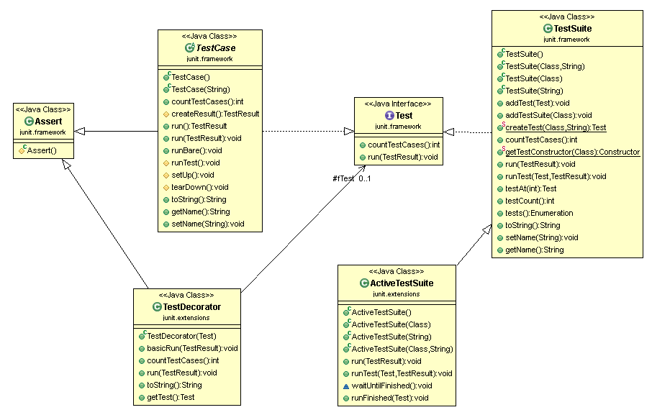

Figure 3‑1 UML class diagram overview for this project.

## 3.2 Problem analysis

Provide any analysis of the problem, leading to a greater understanding

There should be no decisions made in this chapter

# **Chapter four: The Solution**

## Summary

The purpose of this chapter is to clearly identify, discuss, and justify the decisions you make

## Depending on your type of project, you may not need to include all of these:

## 4.1 Analytical Work

E.g. Equations, etc. that describe your solution

## 4.2 Architectural Level

E.g. Implementation Diagrams

## 4.2 High Level

## E.g. Packages, Class Diagrams, etc.

## 4.2 Low Level

## E.g. Method specifications, Algorithms, etc.

## 4.2 Implementation

Discuss anything interesting here; put full source code in an appendix or attachment

# **Chapter five: Evaluation**

## Summary

Chapter 5 describes……..

## 5.1 Solution Verification

## E.g. use your equations to verify the correctness of your solution

## 5.2 Software Design Verification

How did you show that your design worked properly?

Using a model of your solution. E.g. use UML interaction diagrams to verify each scenario.

## 5.3 Software Verification

How did you demonstrate your software worked properly?

If you have not tested your software, then you cannot rely on your results. Clearly describe:

### 5.3.1 Your test approach (i.e. unit testing, sub-system testing, system testing)

### 5.3.2 Your tests (e.g. scenarios, test cases, test data, etc.)

### 5.3.3 Your test results

### 5.3.4 An interpretation of the results

## 5.4 Validation/Measurements

How did you measure how well your solution solved the problem.

### 5.4.1 Results

### 5.4.2 Explanation of Results

### 5.4.3 Analysis of Results

### 5.4.4 Comparison with previous solutions (if relevant)

**Chapter five: Conclusion**

**Summary**

Chapter 5 identifies and discuss the implications of your work.

**5.1 Contribution to the state-of-the-art**

If you made a contribution to the state-of-the-art, clearly identify it here.

**5.2 Results discussion**

Discuss whether your results are general, potentially generalizable, or specific to a particular case. Identify threats to the validity of your results (e.g. limitations, risks introduced by your approach, etc.)

**5.3 Project Approach**

Discuss your project approach

**5.3 Future Work**

Discuss future work, based on what you have done (and not done)

# **References**

Earhart, W., & Clarke, E. (1936). Music in Everyday Life. *Music Educators Journal*, *22*(4), 65. https://doi.org/10.2307/3384690

Quinn, B. (2006). Problematising “Festival Tourism” : Arts Festivals and Sustainable Development in Ireland. *Journal of Sustainable Tourism*, *14*(3), 288–307. https://doi.org/10.1080/09669580608669060

**Appendices**

Include here all extra material, e.g. your source code, project management (optional) including: the task list, Gantt Chart diagrams (or equivalent), discussion of any significant deviations from plan, and how you managed them, discussion of what you would do differently if you repeated the project.

## Appendix 1 Schematic of the hardware associated with this project.

## Appendix 2 Code developed for this project.

## Appendix 3 UML Class, Use Case and sequence diagrams for this project.

|  |
| --- |
|  |
| Appendix 4 Screen shots of the project implementation |
|  |